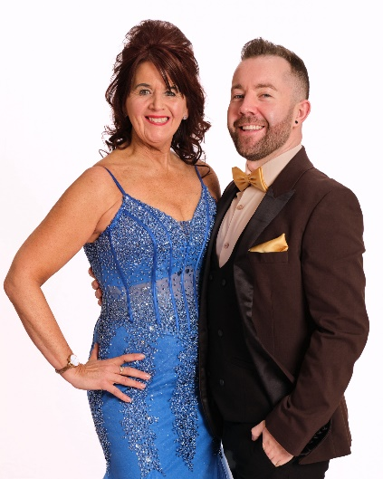
SPACE IN MY HEART
Choreographed by Gary O’Reilly (IRE) & Maggie Gallagher (UK) April 2024
32 Count 4 Wall Improver Level Linedance
Music: Space In My Heart by Enrique Iglesias & Miranda Lambert (2:58)
Intro: 8 counts.

S1: CROSS, SIDE, BEHIND, POINT, CROSS, SIDE, BEHIND SIDE CROSS
1-2 Cross right over left, Step left to left side
3-4 Cross right behind left, Point left to left side
5-6 Cross left over right, Step right to right side
7&8 Cross left behind right, Step right to right side, Cross left over right

S2: SIDE ROCK, RECOVER, CROSS SHUFFLE, SIDE ROCK ¼, L SHUFFLE
1-2 Rock right to right side, Recover on left
3&4 Cross right over left, Step left to left side, Cross right over left
5-6 Rock left to left side, ¼ right recovering on right [3:00]
7&8 Step forward on left, Step right next to left, Step forward on left

S3: ROCK, RECOVER & ROCK, RECOVER, WALK BACK, WALK BACK, L COASTER CROSS
1-2 Rock forward on right, Recover on left
&3-4 Step right next to left, Rock forward on left, Recover on right
5-6 Walk back on left, Walk back on right
7&8 Step back on left, Step right next to left, Cross left over right

S4: SIDE ROCK, RECOVER, SAILOR STEP, CROSS ROCK, RECOVER, CHASSE L
1-2 Rock right to right side, Recover on left,
3&4 Cross right behind left, Step left to left side, Step right to right side
5-6 Cross rock left over right, Recover on right
7&8 Step left to left side, Step right next to left, Step left to left side [3:00]

TAG: At the end of Wall 3, dance the following 8 count Tag:
R CROSS ROCK, RECOVER, CHASSE R, L CROSS ROCK, RECOVER, CHASSE L
1-2 Cross rock right over left, Recover on left
3&4 Step right to right side, Step left next to right, Step right to right side
5-6 Cross rock left over right, Recover on right
7&8 Step left to left side, Step right next to left, Step left to left side
Then restart the dance from the beginning facing [9:00]

ENDING: Dance 30 counts of Wall 9 [3:00], then add the ending to finish facing [12:00]:
CHASSE ¼ L, STEP FORWARD
Step left to left side (7), Step right next to left (&), ¼ left stepping forward on left (8), Step forward on right (1)

Contact:
Gary O’Reilly - oreillygaryone@gmail.com - +353857819808
https://www.facebook.com/gary.reilly.104 - www.thelifeoreillydance.com
Maggie Gallagher - +44 7950291350
www.facebook.com/maggiegchoreographer - www.maggieg.co.uk

